

*Version 1.0 approved*

*Prepared by FCIH-Group 36*

*Helwan University*

*18/10/2018*

**System Documentation of:**



**Electronic Health Record**

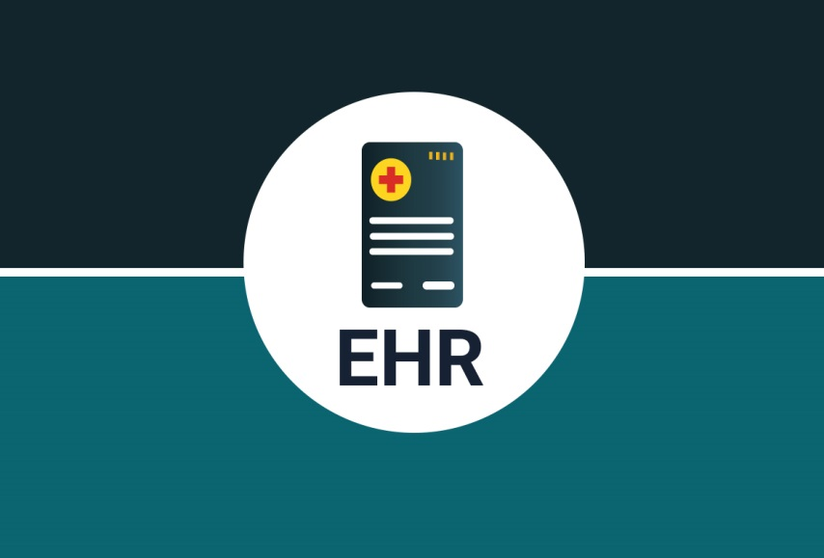

“EHR”

|  |  |
| --- | --- |
| **Name** | **ID** |
| Abdullah Mohamed Kamal | 20150325 |
| Omar Gamal lahzy | 20150350 |
| Abd elfattah Ramadan Abd ekfattah | 2015319 |
| Mohammed Ashraf Ibraheem | 20150418 |
| Noran Mahmoud Yahia | 20150596 |



Faculty of computers system &

Information Systems Department

Supervised by:

DR. Manal Abdel-Kader

Team Members

  

Abdullah Mohamed Omar Gamal Abdalfattah Ramadan

 

Mohamed Ashraf Ibraheem Noran Mahmoud

**ACKNOWLEDGEMENT**



First and foremost, we would express our deepest gratitude and appreciation to our advisor Dr. Manal Abdel-Kader for her support,

Outstanding guidance and encouragement throughout our graduation Project.

As well as Aman Hospital their continuous support and help as

Major of Aman’s Doctors was always there helping us for providing more than the needed time and effort from them since the very beginning of our project.

We would also like to thank our families, especially our parents, for their encouragement, patience, and assistance over the years.

We are forever indebted to our parents, who have always kept us in their prayers and pushed us to Success.

Finally, for our faculty for providing the suitable environment that leaded us to represent the best image that computer science graduates Of Helwan University are supposed to represent.

Table of Contents

Presented page 2

Acknowlegement page 3

Table of Contents 4

Chapter 1 : Introduction

1.1 Purpose 7

1.2 Document Conventions 7

1.3 Intended Audience and Reading Suggestions 8

1.4 Product Scope 8

1.5 References 9

Chapter 2 : project "Planning & Analysis "

2. 1 Overall Description 10

2.1.1 Product Perspective……………………………………………………………………………………………………….….10

2.1.2 Product Functions 11

2.1.3 User Classes and Characteristics 11

2.1.4 Operating Environment 12

2.1.5 General Constraints 13

2.1.6 User Documentation 14

2.1.7 Assumptions and Dependencies 14

2.2 External Interface Requirements 15

2.2.1 User Interfaces 15

2.2.2 Communications Interfaces 21

2.3 Analysis System Requierment 22

2.3.1 User Requierments 22

2.3.1 .1 Mondatory Requierments 22

2.3.1.2 DesirableRequierments 22

2.3.1.3 Optional Requierments 22

2.3.4 System function Requierments 23

2.3.5 System non function Requierments 37

2.3.6 Use-case senario 39

Chapter 3 : project "Design "

3.1 Use-case Diagram 47

3.2 Activity Diagram 51

3.3 Sequence Diagram 61

3.4 Design of Database 71

3.5 Class Diagram 72

Chapter 4 : project "implemention "

4.1 Hardware Architecture 74

4.1 software Architecture 75

**Chapter 5: project "Testing "**

5.1 Unit Testing 80

5.2 Integrated Testing 81

5.3 Additional Testing 82

conclusion page 87

Thanks page 88

In this chapter we’re going to discuss and go deeper in the overview of the project and know more about its scope and limitations, and explain some terminologies we will find throughout the document.

**Chapter 1**: Introduction

## Purpose

The main purpose of our EHR is to get rid of all paper work that is being done by doctors in hospitals and laboratories by using an automated system that make it easier for patient doctor ,hospitals ,laboratories and pharmacy .Helping hospitals and clinics to keep track of their Patient health history and select the best doctors in their field . Help doctors to write patient prescription automatically, identify illness quickly by seeing patient history and using a high reference of Model prediction to predict heart danger diseases. Help patient to treat with any medical place automatically by using a smart card which contain high **QR** without using any paper prescription. Helping pharmacy to get rid of queues by only just receives prescription online to confirm it and so on for laboratory which make the result into the patient account and add into his history. The life will become so easy for anyone here and the patient will not be worried to lose prescription, lab result or radiation result.

## Document Conventions

This document will use IEEE format for clarity, acronyms and technical jargon, deemed uncommon by the author, will be annotated and included in the glossary. Standard IEEE template is the template used to organize the appearance of the document and its flow.

The document is prepared using Microsoft word 2010.The format for heading is as followed:

Major headings are in **bold18pt font**, concurrent headings in **bold 14pt font** but the fixed font size will be 12pt font with 1.5 line spacing. All pages expect the cover page are numbered, the numbers appear on the higher right hand corner of the page. Every image and data table are numbered and referred to the in main text. Sections are in the format of x .y, where x. y are real, positive integers.

## Intended Audience and Reading Suggestions

This document is intended for Developers, marketing staff, testers, Graduation project doctor, developers who might like to continue this project and all medical places of (hospitals, clinics, pharmacy, laboratories) with doctors and patients.

Recommendation to start reading from:

**1. Developers:** overall description, system features then nonfunctional requirements.

**2.** **Marketing stuff:** overall description then external interface requirements.

**3.** **Testers:** everything.

**4.** **Graduation project doctors:** introduction, overall description, system features then nonfunctional requirements.

**5.** **Developers who might like to continue this project:** everything.

**6. All medical places of (hospitals, clinics, pharmacy, laboratories) with doctors and patients:** using our HER system with all features

## Product scope

The electronic health record system is an online website and Android application allows patient to have a medical profile that contains his prescription, medicines, and lab analyses. Patient has an ID with smart **QR** which carries his information. Doctor, pharmacy, lab doctors can see his medical history. The doctor can add data to the patient history. The data goes to pharmacy and lab at the time of upload it. Patient can go immediately to get his medicine without waiting in a queue and lab is the same. System notify patient who has a doctor appointment. Patient can review doctor, pharmacy, lab and hospital and giving him Rate for their efforts and services. He can also see our partners from hospitals, pharmacies and labs. However, our system can predict heart diseases of patient by using a high model prediction. In addition to our system making a high analysis of all information in system and write it into statistics to read it easy. Using **NPS** process of making filtration of patient comments depend on Rate. Finally, our EHR can reset password for patient

E-mail in the case of losing password.

## References

* Framework: Django (python high-level framework)
* EHR Information Resource: <https://www.healthit.gov/>
* Github: <https://github.com/abdullah12388/EHR-project>
* NPS: [https://www.hotjar.com/net-promoter-score](https://www.hotjar.com/net-promoter-score?fbclid=IwAR0XZ3fHkqF1WYvaxR5CscdygKyFBswpwAZrq1Z7Snv6Q5UOwEi92l1m9ww)
* Model Prediction: [https://github.com/abdullah12388/Heart-disease-predicition](https://github.com/abdullah12388/Heart-disease-predicition?fbclid=IwAR2yT2BxzrRWhQYE_KrSU34uRvIRSZDaZsAnIy0aF8qYYye5JmxJupbQX5w)
* Model Explain: EHR-project\big data\csit42607.pdf
* RSS Feed : <https://www.tutorialspoint.com/python/python_reading_rss_feed.htm>

**Chapter 2**: project planning

And analysis

In this chapter we’re going to discuss and go deeper in how we plan the

Project and show the steps and the instructions that we’ve followed to

Plan the system.

# Overall Description

## Product Perspective

Our system web-based, Android Application, self-contained system and independent software and semi Hardware product.

It manages activities of the hospital, clinic, pharmacy, laboratory and radiation center as patient info.

It’ll not require any browser but it’ll need an external interface include keyboard, mouse, enabling navigation across screens and sensor or camera to read QR of patient ID.

Or using smart phone of Android app

Several of users will use our system such as patient, doctor, HR, Admin, pharmacy and laboratory but, at the same time there’re can’t do anything on our system without permission to access.

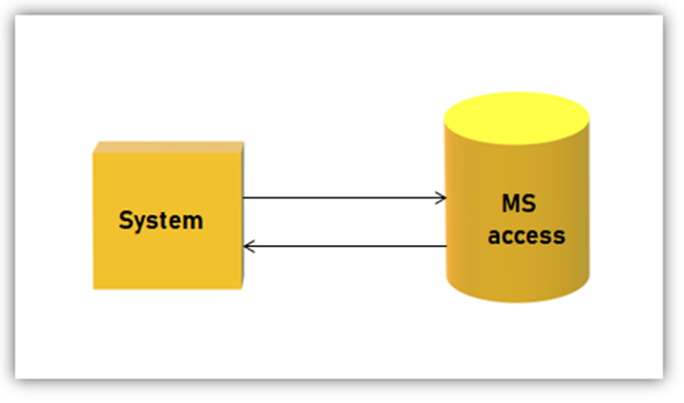

## Product Functions

One of the major functions is to store the patient data by a doctor or a staff member and also to have doctor appointment time in visible to the user and all his illness history which help in analysis to find if there is a new disease is spreading also the patient , doctor and staff can create account on the system the pharmacist can view only the medicine of the patient the doctor have written and the medicine for him and this and also their a statistics about the medicines and the lap result are add to the patient history.

* The main supposed functions to be coded in this App are:-

-Register -Login

-Logout -Reset password

-Scan ID (QR) -predict Heart Risk

-Search -Comment

-Rate -Feedback

-Notification -Search

-Send Results -confirmation

-Add (Hospital,clinic,doctor,pharmacy,lab)

-Delete (Hospital,clinic,doctor,pharmacy,lab)

-Block (Hospital,clinic,doctor,pharmacy,lab)

-Write (prescription,Ray,Medicine,Analytics)

-Update (prescription,Ray,Medicine,Analytics)

-statistics

## User Classes and Characteristics

One of the main users of system is:

The **Admin** can: add/block Hospital, Clinic, Doctor, Lab, unauthenticated patient and view/follow up all the system.

The **Hospital/Clinic** can: add/block doctors, view all doctors (data, Rate). It can also see our partners from hospitals, pharmacies and labs.

The **Doctor** can: View patient history, add/update to the patient history, add/update the medicine name, add/update Ray name, add/update Analytics name by using voice recognition or by writing the name.

The **Pharmacist** can: view only the patient medicine of his prescription that he is taking and can view statistics about the medicine.

The **lap doctor** can add the patient lap result to his account, view previous lap results and view statistics about lap result of all patients.

The **Patient** can view his account, update his personal data and have a smart card that he uses to give to a doctor or any of the staff to access the specific data they need.

## Operating Environment

* **System Requirement (Hardware) :**
* CPU: at least Dual core 3.6 MHZ.
* Processor: Pentium IV 2 GHZ and all above.
* Space: minimum of 500 MB.
* Monitor: VGA color monitor.
* Sensor or camera
* Ram: minimum of 1 GB.
* Smart card (ID): QR
* Smart phone
* **System Requirement (Software) :**
* Main programming language: python.
* other programming language: html, css, java script, Bootstrap
* Operating system: Windows XP and all above.
* Browser: Mozilla fire fox, Microsoft internet explorer or Google chrome.
* Web service: Django (framework).

1. python -m pip install --upgrade pip
2. pip install virtualenv
3. pip install django==2.0.5
4. pip install --upgrade django-crispy-forms
5. pip install bcrypt
6. pip install django[argon2]
7. pip install django-mysql
8. pip install --only-binary :all: mysqlclient
9. pip install Pillow
10. pip install qrcode
11. pip install opencv-python
12. pip install pyzbar
13. pip install djangorestframework
14. pip install markdown
15. pip install django-filter
16. pip install sklearn

## GENERAL CONSTRAINTS

* Tasks division which can be not fair enough.
* Indiscipline “Human factor” like being late in delivering tasks or attending meetings
* Hesitation, especially when it’s related to taking a serious step or learning a new technique
* Time management
* Learning new technologies may take much time
* Underestimating the objectives that may not lead to realistic or achievable function

## User Documentation

* The Documentation should mainly include these main chapters:-
* Introduction: includes an overview of the project and limitations
* Project Planning: includes the tools and technologies as well as tasks and timeline plan
* Project Requirements: includes the functional and non-functional requirements
* Project Design: includes the diagrams
* Project Implementation: includes user application administrator system
* Project Testing: includes all testing types

## Assumptions and Dependencies

We assume that we will be the first one to build this project and make it in public. We will face some issues which will be: we do not have any data set to work on, so we built it from scratch. We assume that we will face a host problem because we want a secret one that can provide a good space and high security at the same time. We will create a new data set to work on to do our transactions.

* EHR: Electronic Health Record.
* QR: as the meaning of smart card patient ID which has specific mark.
* NPS: as the meaning of filtration all patient comments depend on Rate.

# External Interface Requirements

## User Interfaces

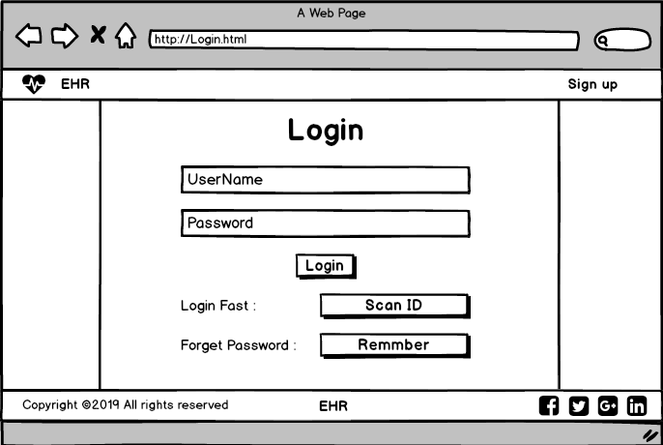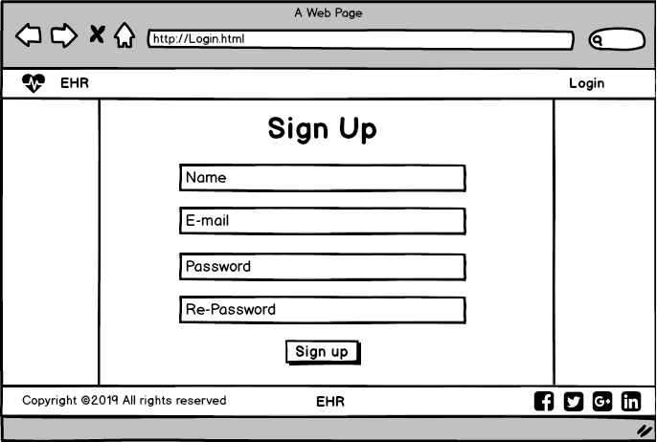

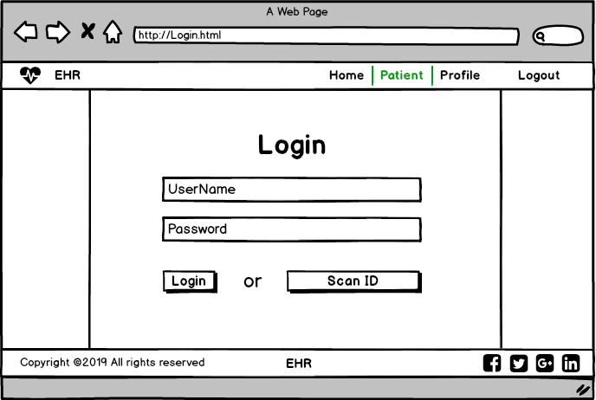

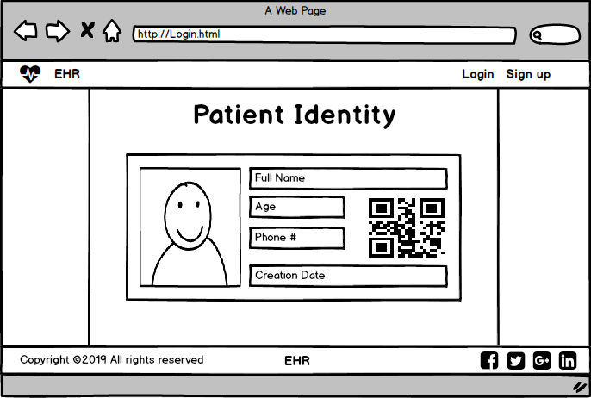

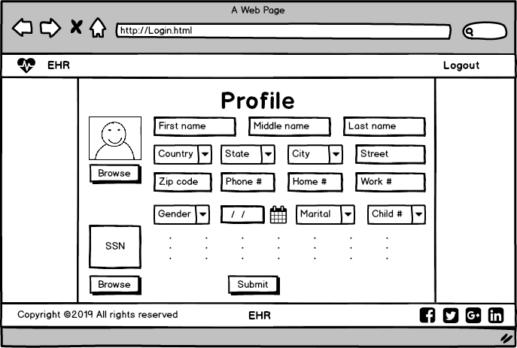

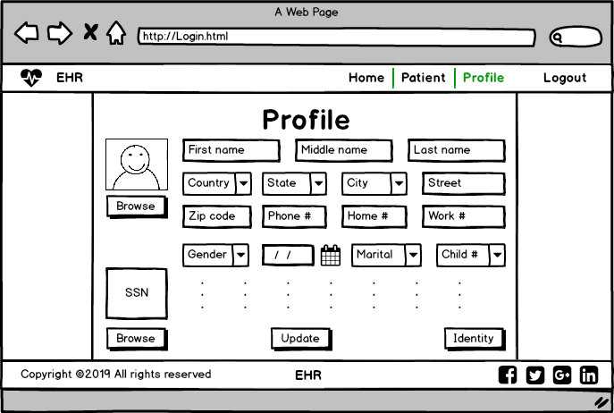

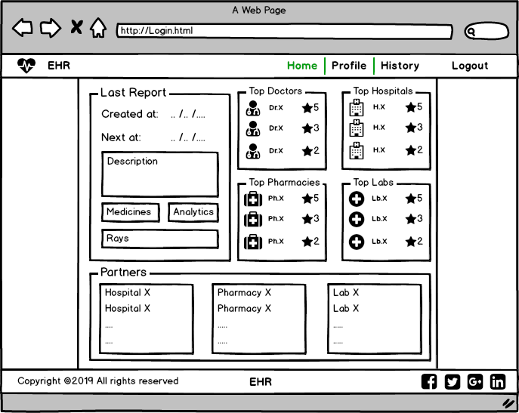

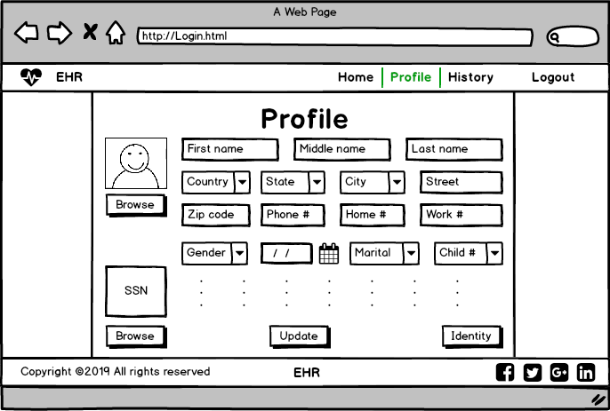

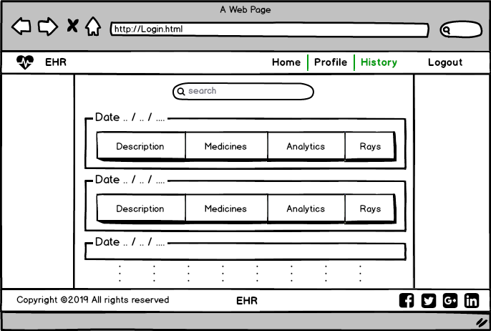

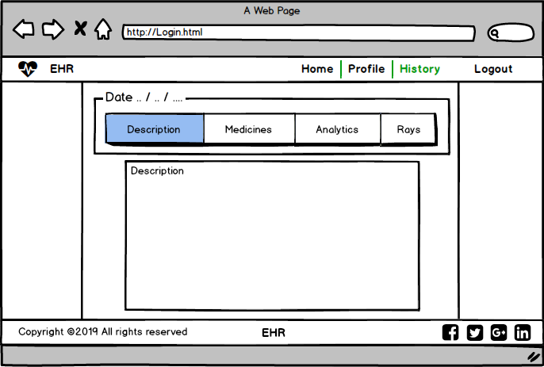

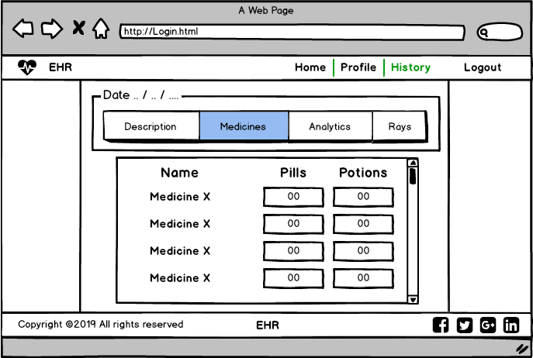

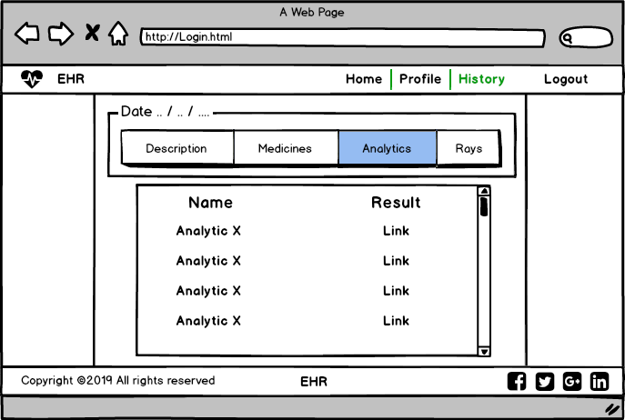

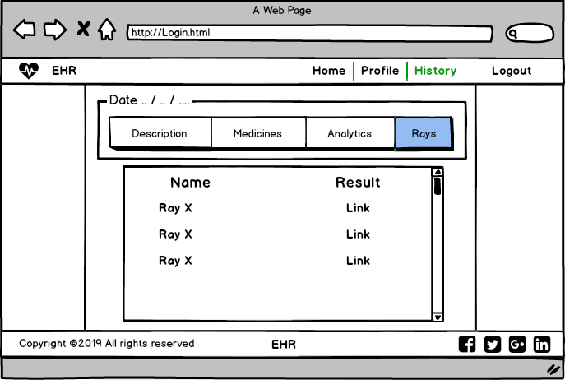

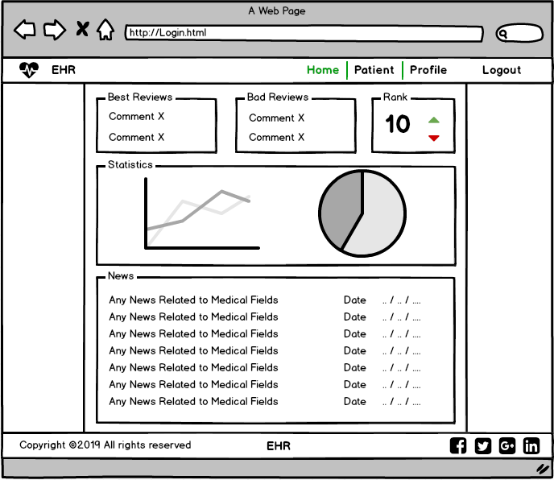

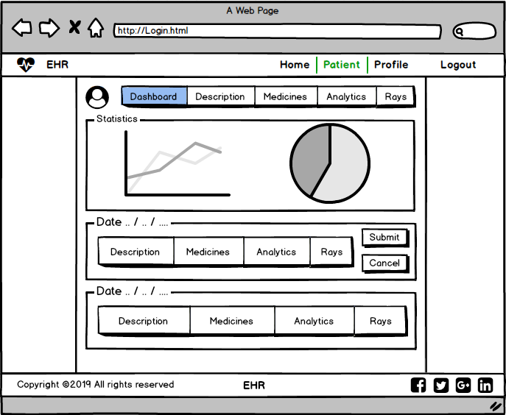

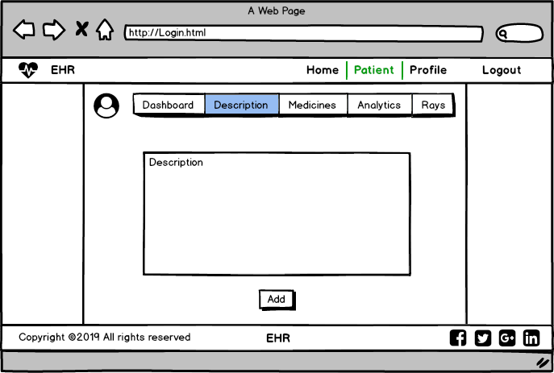 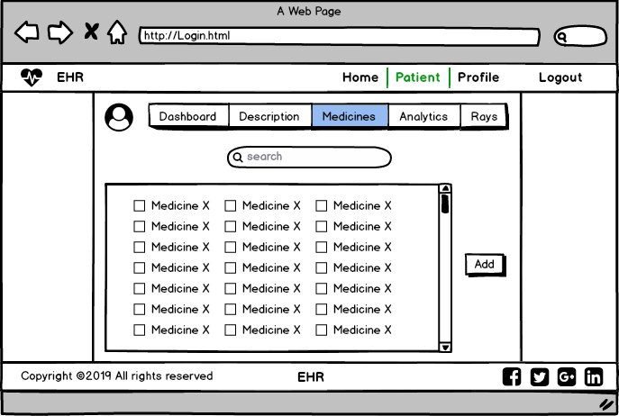

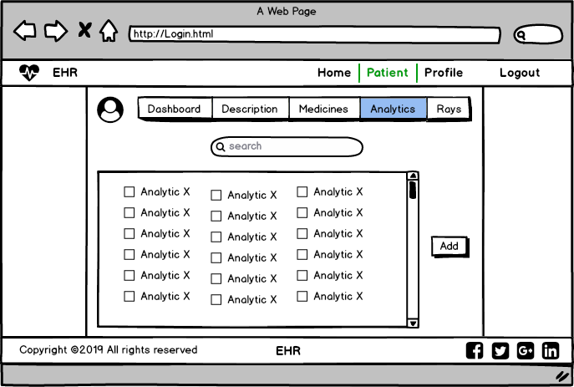

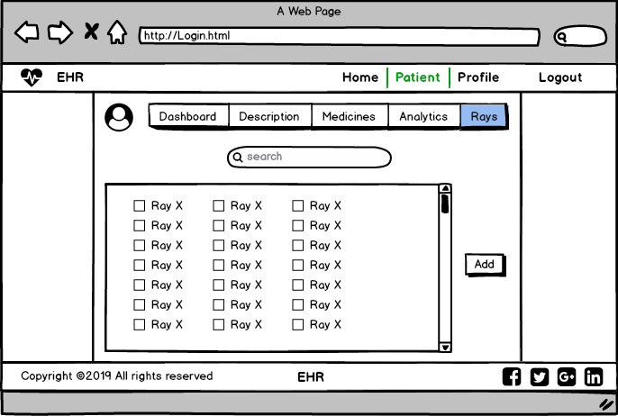

## Communications Interfaces

<Describe the requirements associated with any communications functions required by this product, including e-mail, web browser, network server communications protocols, electronic forms, and so on. Define any pertinent message formatting. Identify any communication standards that will be used, such as FTP or HTTP. Specify any communication security or encryption issues, data transfer rates, and synchronization mechanisms.>

# Analysis System Requirement

## User requirements:-

## Mandatory requirements:

1- The user searches for any app or site to transfer all paper working in technical work at any place easily only by few clicks without need to broker so we will cover this point in medical field in our site.

2-The user not only needs that but also needs to notify by all doctor appointment and show more about good doctors , so we will cover all this categories in our system.

## Desirable requirements:

1- The user needs to use GPS to make the process of finding clinics and hospitals easily so, we will provide this feature in our app.

2- The user uses the app with him at any place and any time so our app should be available in any place and any time.

## Optional requirement:

1. The users prefer a social media part to communicate with each other so, we will provide this feature in our app.

## function Requirements

|  |  |
| --- | --- |
| **Code** | F1 |
| **Name** | Log in |
| **Role** | Admin – client – HR – Lab – Pharmacy – Doctor |
| **Type** | Functional Requirement |
| **Description** | Give the actors a permission to do there functions and access the system features |
| **Pre-Condition** | Has a computer or mobile and internet connection |
| **Post-Condition** | Open log in page |
| **Input** | Enter log in required information |
| **Output** | Accept/reject log in action |

|  |  |
| --- | --- |
| **Code** | F2 |
| **Name** | Register |
| **Role** | Admin – client – HR |
| **Type** | Functional Requirement |
| **Description** | Take the required information from the actors, check if exists or not and make him an new account with some steps to log in our system successfully |
| **Pre-Condition** | Not registered before, has a computer or mobile and internet connection |
| **Post-Condition** | Open register page |
| **Input** | Enter register required information |
| **Output** | Accept/reject register action |

|  |  |
| --- | --- |
| **Code** | F3 |
| **Name** | Show data |
| **Role** | Lab – Pharmacy |
| **Type** | Functional Requirement |
| **Description** | General function allows actors to see kind of data related to his access for example lab can see rays and analytical data, pharmacy can see medicine data |
| **Pre-Condition** | Must has an account |
| **Post-Condition** | Log in with the account |
| **Input** | Action from show data button |
| **Output** | Open data page |

|  |  |
| --- | --- |
| **Code** | F4 |
| **Name** | Show Reviews |
| **Role** | Client |
| **Type** | Functional Requirement |
| **Description** | It's a function allows the client to see the hospital, doctor, lab and pharmacy reviews and ranking |
| **Pre-Condition** | Must has an account |
| **Post-Condition** | Log in with the account |
| **Input** | Press show reviews button |
| **Output** | Open reviews page |

|  |  |
| --- | --- |
| **Code** | F5 |
| **Name** | Show History |
| **Role** | Client – Doctor |
| **Type** | Functional Requirement |
| **Description** | This function allows actors to see the whole medical history from doctor description to the medicine and rays…etc |
| **Pre-Condition** | User must has an account |
| **Post-Condition** | Log in with his account |
| **Input** | Action from the history button |
| **Output** | Show the page of all data |

|  |  |
| --- | --- |
| **Code** | F6 |
| **Name** | Edit Personal Data |
| **Role** | Client – HR |
| **Type** | Functional Requirement |
| **Description** | This function allows the actors to edit their personal data like name and address and so on |
| **Pre-Condition** | Must has an account |
| **Post-Condition** | Log in with his account |
| **Input** | New data |
| **Output** | Notification with successful editing and open profile |

|  |  |
| --- | --- |
| **Code** | F7 |
| **Name** | Get Doctor Appointment Notification |
| **Role** | Client |
| **Type** | Functional Requirement |
| **Description** | This function send a notification message to the patient remember him with the doctor appointment |
| **Pre-Condition** | Have an account, has a meeting with doctor |
| **Post-Condition** | Log in with his account |
| **Input** | Automatic input from doctor schedule |
| **Output** | Notification message with doctor appointment |

|  |  |
| --- | --- |
| **Code** | F8 |
| **Name** | Show Our Partners |
| **Role** | Client |
| **Type** | Functional Requirement |
| **Description** | This function allows the actor to know our partners like hospitals, pharmacies and labs to go to the nearest one |
| **Pre-Condition** | Must has an account |
| **Post-Condition** | Log in with his account |
| **Input** | Press show our partners button |
| **Output** | Open partners page |

|  |  |
| --- | --- |
| **Code** | F9 |
| **Name** | Add Clinic |
| **Role** | Admin |
| **Type** | Functional Requirement |
| **Description** | The admin uses this function to add a clinic as an organization to our system and make the doctor responsible for it |
| **Pre-Condition** | Must has an account with admin permission |
| **Post-Condition** | Log in with his account |
| **Input** | Clinic and doctor data |
| **Output** | Clinic info and doctor profile |

|  |  |
| --- | --- |
| **Code** | F10 |
| **Name** | Add Hospital |
| **Role** | Admin |
| **Type** | Functional Requirement |
| **Description** | The admin uses this function to add a hospital as an organization to our system and make the HR responsible for it |
| **Pre-Condition** | Must has an account with admin permission |
| **Post-Condition** | Log in with his account |
| **Input** | Hospital data |
| **Output** | Hospital info added successfully |

|  |  |
| --- | --- |
| **Code** | F11 |
| **Name** | Remove Clinic |
| **Role** | Admin |
| **Type** | Functional Requirement |
| **Description** | This function allows the admin to delete and block the clinic from our system so we have not to deal with it anymore |
| **Pre-Condition** | Must has an account with admin permission |
| **Post-Condition** | Log in with his account |
| **Input** | Action from remove clinic button |
| **Output** | Notification of successful removing |

|  |  |
| --- | --- |
| **Code** | F12 |
| **Name** | Remove Hospital |
| **Role** | Admin |
| **Type** | Functional Requirement |
| **Description** | This function allows the admin to delete and block the hospital from our system so we have not to deal with it anymore |
| **Pre-Condition** | Must has an account with admin permission |
| **Post-Condition** | Log in with his account |
| **Input** | Action from remove hospital button |
| **Output** | Notification of successful removing |

|  |  |
| --- | --- |
| **Code** | F13 |
| **Name** | Add Hospital HR |
| **Role** | Admin |
| **Type** | Functional Requirement |
| **Description** | The admin uses this function after add a hospital department to add a person managing the hospital system  (human resource person) |
| **Pre-Condition** | Must has an account with admin permission |
| **Post-Condition** | Log in with his account |
| **Input** | Data of the hospital hr |
| **Output** | Notification of successful adding |

|  |  |
| --- | --- |
| **Code** | F14 |
| **Name** | Show Statistics |
| **Role** | Admin – lab – pharmacy – doctor |
| **Type** | Functional Requirement |
| **Description** | This is a general function allows actors to see statistics about the system but with different views for each actor |
| **Pre-Condition** | Must have an account |
| **Post-Condition** | Log in with the account |
| **Input** | Action from show statistics button |
| **Output** | Open statistics page |

|  |  |
| --- | --- |
| **Code** | F15 |
| **Name** | Upload X-Rays |
| **Role** | Lab |
| **Type** | Functional Requirement |
| **Description** | Get x-ray from a scanner and uploaded to the system and can be saved as pdf file where a doctor can access it and will much clearer |
| **Pre-Condition** | Must has an account |
| **Post-Condition** | Log in with the account |
| **Input** | Action from press upload x-ray button |
| **Output** | A Pdf form of the x-rays |

|  |  |
| --- | --- |
| **Code** | F16 |
| **Name** | Add Analytics |
| **Role** | Lab |
| **Type** | Functional Requirement |
| **Description** | A feature helps the lap doctor add the analysis result of the patient to his/her account |
| **Pre-Condition** | Must has an account |
| **Post-Condition** | Log in with the account |
| **Input** | Action from press add analytics button |
| **Output** | Add analytics done successfully |

|  |  |
| --- | --- |
| **Code** | F17 |
| **Name** | Check & Submit Result |
| **Role** | Lab – pharmacy |
| **Type** | Functional Requirement |
| **Description** | Check the data of the medicine and the analysis are correct and confirm it |
| **Pre-Condition** | Have an account and Patient data already entered |
| **Post-Condition** | Log in with the account |
| **Input** | Press confirm and submit button |
| **Output** | Accept/reject data entered |

|  |  |
| --- | --- |
| **Code** | F18 |
| **Name** | Add Patient Data |
| **Role** | Doctor |
| **Type** | Functional Requirement |
| **Description** | This general function allows the doctor to add the patient history or medical data and upload it in the system |
| **Pre-Condition** | Must has an account |
| **Post-Condition** | Log in with the account |
| **Input** | Action from press add patient data button |
| **Output** | Add data done and uploaded successfully |

|  |  |
| --- | --- |
| **Code** | F19 |
| **Name** | Show Doctor Ranks |
| **Role** | Functional Requirement |
| **Type** | Doctor |
| **Description** | This function allows the doctor to see his rank in our system |
| **Pre-Condition** | Must has an account |
| **Post-Condition** | Log in with the account |
| **Input** | Action from press show doctor rank button |
| **Output** | Ranking page will open |

|  |  |
| --- | --- |
| **Code** | F20 |
| **Name** | Block Doctors |
| **Role** | HR |
| **Type** | Functional Requirement |
| **Description** | This function helps the hr to delete the doctor from the hr's hospital that mean the doctor leave it and didn't work their anymore |
| **Pre-Condition** | Must has an account |
| **Post-Condition** | Log in with the account |
| **Input** | Action from press block doctor button |
| **Output** | Notification with doctor removed successfully |

|  |  |
| --- | --- |
| **Code** | F21 |
| **Name** | Search |
| **Role** | HR |
| **Type** | Functional Requirement |
| **Description** | This function helps the hr to find the doctor in our system by writing his name |
| **Pre-Condition** | Must has an account |
| **Post-Condition** | Log in with the account |
| **Input** | Doctor name |
| **Output** | Matching results to the doctor name |

# System Nonfunctional Requirements

|  |  |
| --- | --- |
| **Name** | Dependability |
| **Type** | Product requirements |
| **Description** | Maintaining system & facing any kind of  Threats |

|  |  |
| --- | --- |
| **Name** | Testability |
| **Type** | Product requirements |
| **Description** | Testing system and code of functionality and  find bugs to ensure its performance |

|  |  |
| --- | --- |
| **Name** | Maintainability |
| **Type** | Product requirements |
| **Description** | The ability of Fixing and updating the system  to ensure its stability |

|  |  |
| --- | --- |
| **Name** | Portability |
| **Type** | Usability requirements |
| **Description** | The ability to use the software on different  Platform |

|  |  |
| --- | --- |
| **Name** | Robustness |
| **Type** | Usability requirements |
| **Description** | Handling errors, exceptions and invalid data |

|  |  |
| --- | --- |
| **Name** | Reliability |
| **Type** | Usability requirements |
| **Description** | System maintains its performance over long period of time |

## 3.1 use case scenario

|  |  |
| --- | --- |
| **Use case Name:** | Register |
| **Actors:** | Lab Doctor |
| **Basic Flow:** | 1. Open Home page 2. Click on register button 3. Enter your information 4. Click register button |
| **Pre-conditions:** | Open Registration Page |
| **Alternative flow:** | 1. If Data entered are not vailed 2. The user re-enter information |
| **Post-conditions:** | The Data Saved and the user is Created successfully |

|  |  |
| --- | --- |
| **Use case Name:** | Login |
| **Actors:** | Lab Doctor |
| **Basic Flow:** | 1. Open Home page 2. Click on Login button 3. Enter your information 4. Click Login button |
| **Pre-conditions:** | Open Login Page and Enter email and password |
| **Alternative flow:** | 1. If Data entered are not vailed 2. The user re-enter information |
| **Post-conditions:** | The Data are accepted, and the user is logged in successfully and Send to the home page |

|  |  |
| --- | --- |
| **Use case Name:** | Show Lab Data |
| **Actors:** | Lab Doctor |
| **Basic Flow:** | 1. Open Home page 2. Click on Login button 3. Enter your information Click Login button 4. Go to Profile 5. Press Scan QR 6. Press View information Button |
| **Pre-conditions:** | Must be logged In and Scan QR |
| **Alternative flow:** | 1. QR not Scanned Correctly 2. Rescan QR Code |
| **Post-conditions:** | The Lab Doctor access lab info about specific patient |

|  |  |
| --- | --- |
| **Use case Name:** | Add analytics |
| **Actors:** | Lab Doctor |
| **Basic Flow:** | 1. Open Home page 2. Click on Login button 3. Enter your information Click Login button 4. Go to Profile 5. Scan QR Code 6. Press on Add patient Data 7. Enter Lab result Data 8. Press Add Data |
| **Pre-conditions:** | Must be Logged In /Scan QR Code |
| **Alternative flow:** | 1. The QR not Scanned correctly 2. Rescan the Scan The QR 3. Data are Not Valid 4. Re-enter lab result Data |
| **Post-conditions:** | The patient Data is updated, and the lap result Data are add to his account |

|  |  |
| --- | --- |
| **Use case Name:** | Upload X-rays |
| **Actors:** | Lab Doctor |
| **Basic Flow:** | 1. Open Home page 2. Click on Login button 3. Enter your information Click Login button 4. Go to Profile 5. Scan QR Code 6. Press on Add patient Data 7. Press on choose X-rays 8. Choose X-rays from File 9. Press Upload x-rays |
| **Pre-conditions:** | Must be Logged In /Scan QR Code |
| **Alternative flow:** | 1. The QR not Scanned correctly 2. Rescan the Scan The QR 3. The file not the supported format 4. Re upload the x-rays |
| **Post-conditions:** | The file uploaded successfully to the patient account |

|  |  |
| --- | --- |
| **Use case Name:** | Lab Statistics |
| **Actors:** | Lab Doctor |
| **Basic Flow:** | 1. Open Home page 2. Click on Login button 3. Enter your information Click Login button 4. Go to Profile 5. Press on Show Lap Statistics |
| **Pre-conditions:** | Must be Logged In |
| **Alternative flow:** | n/a |
| **Post-conditions:** | The Lab Doctor will view statistics about all lab results |

|  |  |
| --- | --- |
| Use case Name: | Check and Submit |
| Actors: | Lab Doctor |
| Basic Flow: |  |
| Pre-conditions: |  |
| Alternative flow: |  |

|  |  |
| --- | --- |
| **Use case Name:** | Log in |
| **Actors:** | HR |
| **Basic Flow:** | 1. Open Home page 2. Click on Login button 3. Enter required data 4. Click GO button |
| **Pre-conditions:** | Open login Page |
| **Alternative flow:** | 1. If Data entered are incorrect  2. HR re-enter data required |
| **Post-conditions:** | The Data entered, checked with real data and go to HR’s home page |

|  |  |
| --- | --- |
| **Use case Name:** | Register Doctor |
| **Actors:** | HR |
| **Basic Flow:** | 1. Open Home page   2.Click on Login button  3.Enter required data and Click Login button  4.Go to his home page   1. Press add/register Doctor   6.add all doctor data required |
| **Pre-conditions:** | Open HR home Page |
| **Alternative flow:** | 1.If Data entered are incorrect  2.re-enter doctor data required |
| **Post-conditions:** | A new Doctor added successfully on our system |

|  |  |
| --- | --- |
| **Use case Name:** | Block Doctor |
| **Actors:** | HR |
| **Basic Flow:** | 1.Open Home page  2.Click on Login button  3.Enter required data and Click Login button  4.Go to his home page  5.Press delete/Block Doctor  6.determine doctor  7.press ok |
| **Pre-conditions:** | Open HR home Page |
| **Alternative flow:** |  |
| **Post-conditions:** | Selected doctor deleted successfully |

|  |  |
| --- | --- |
| **Use case Name:** | Search |
| **Actors:** | HR |
| **Basic Flow:** | 1.Open Home page  2.Click on Login button  3.Enter required data and Click Login button  4.Go to his home page  5.Press search Doctor button  6.write doctor name and select it  7.go to this doctor page |
| **Pre-conditions:** | Open HR home Page |
| **Alternative flow:** | 1.If Data entered are not valid  2.HR re-enter doctor name |
| **Post-conditions:** | All Doctors names which follow this name are appeared |

|  |  |
| --- | --- |
| **Use case Name:** | Edit personal data |
| **Actors:** | HR |
| **Basic Flow:** | 1.Open Home page  2.Click on Login button  3.Enter required data and Click Login button  4.Go to his home page  5.Press Edit personal data  6.enter new edit data  7.press save/submit/ok |
| **Pre-conditions:** | Open HR home Page |
| **Alternative flow:** | 1.If Data entered are not valid  2.HR re-enter information and repeat it again |
| **Post-conditions:** | The new Data Saved successfully and appear for him |

**Chapter 3**: Design

In this chapter we’re going to discuss and go deeper in EHR system design

and present its diagrams and database.

## 3.1 usecase diagram

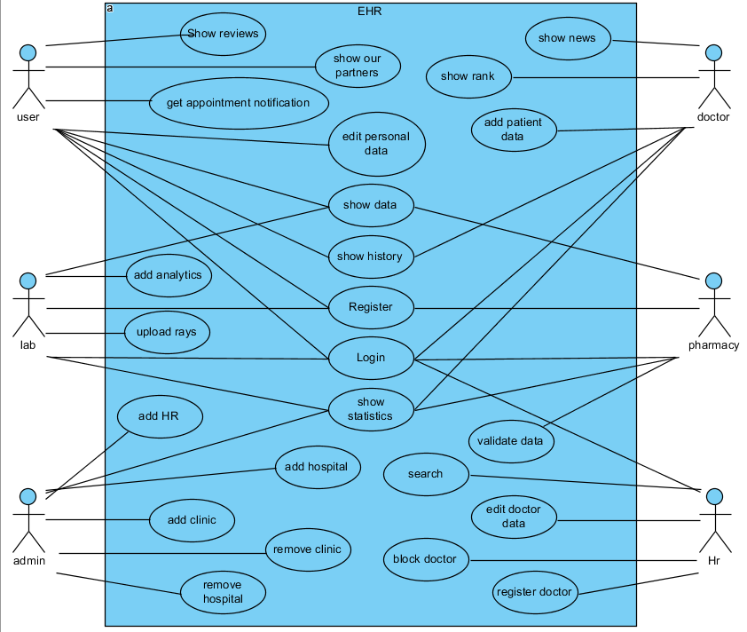

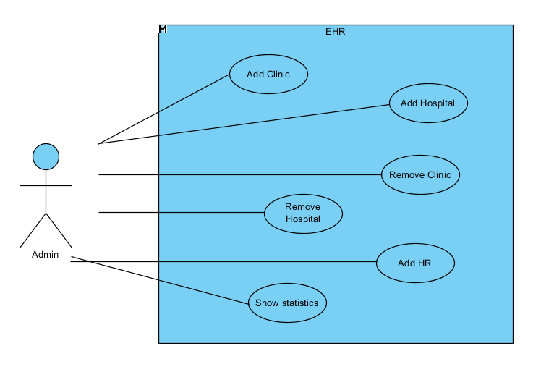

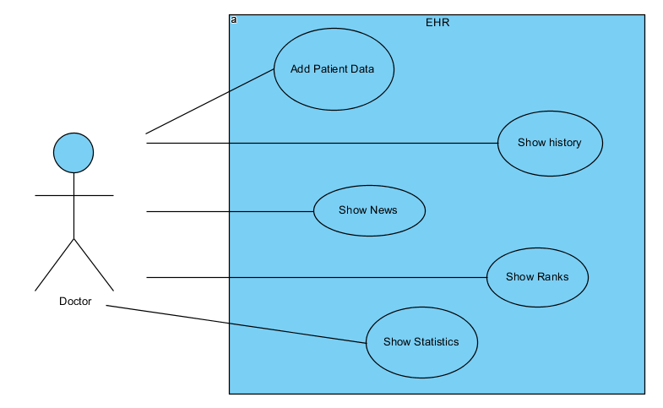

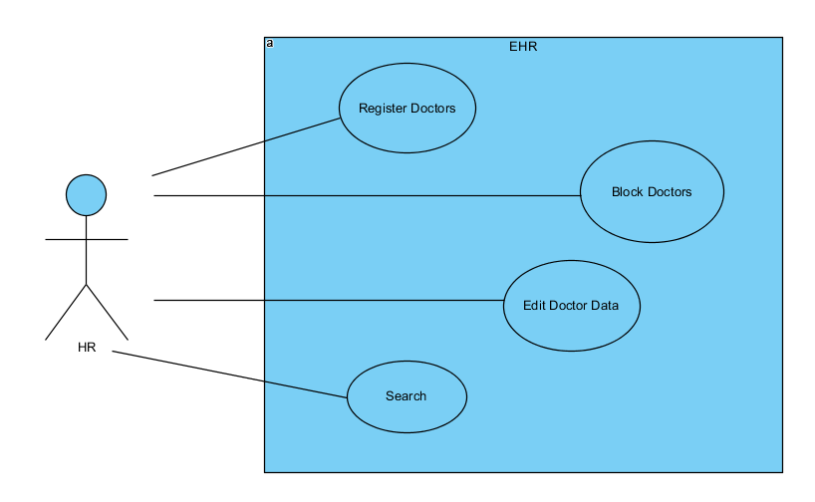

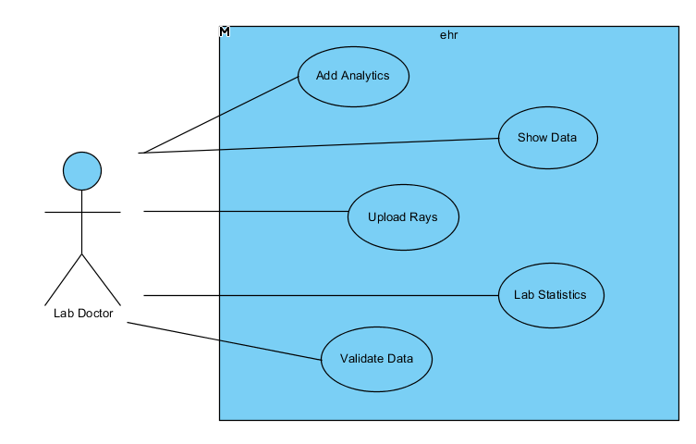

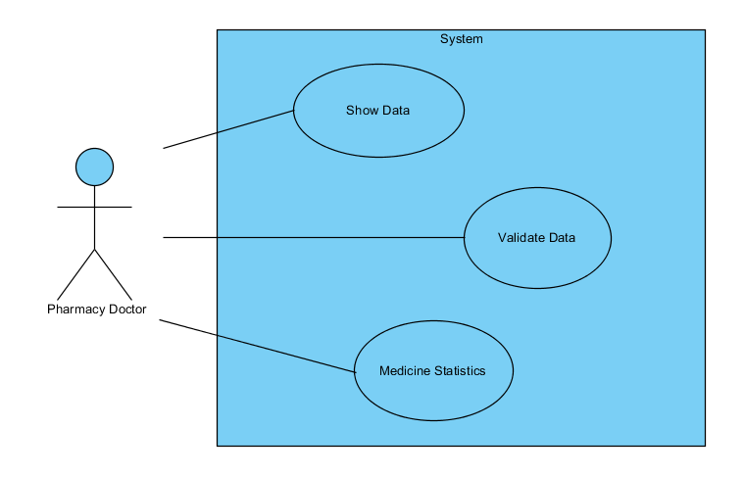

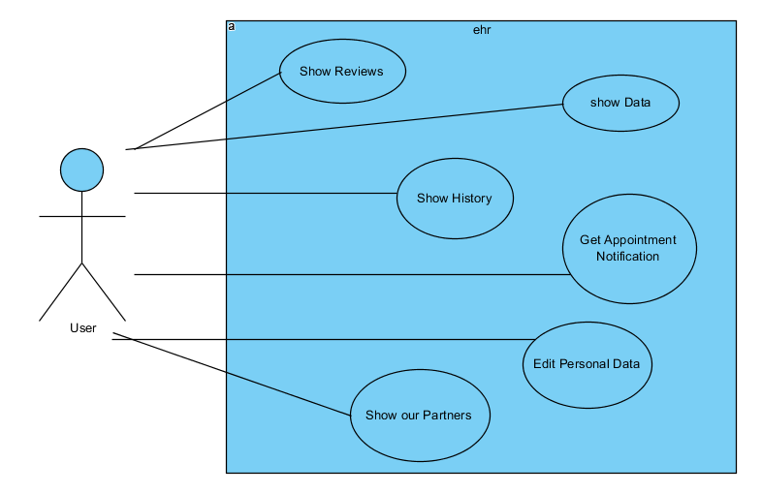

## 3.2 activity diagram

* **Register**

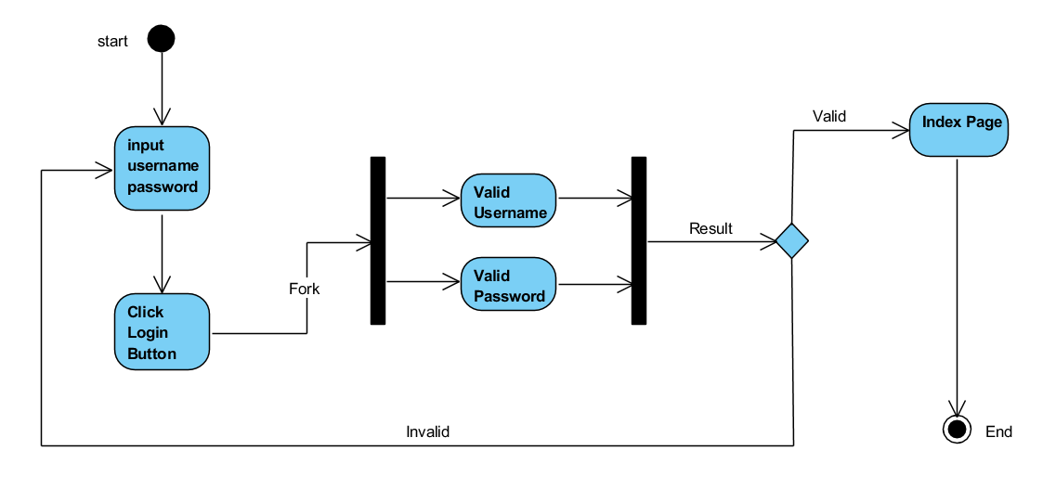

* **Search**

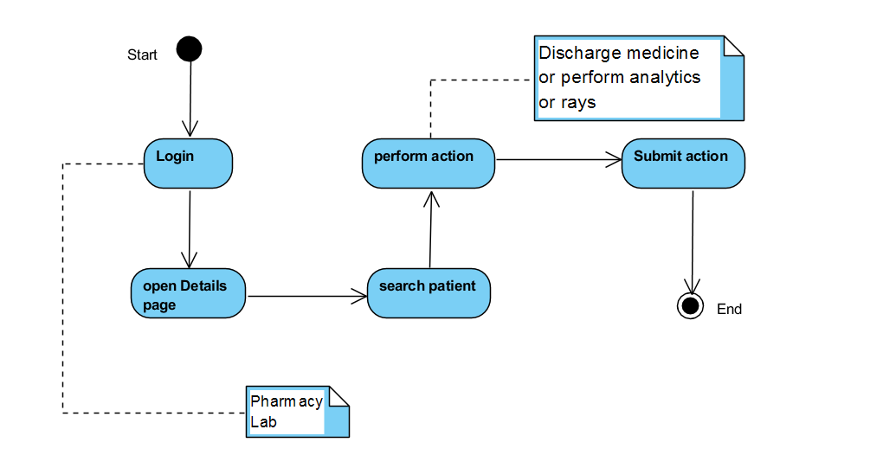

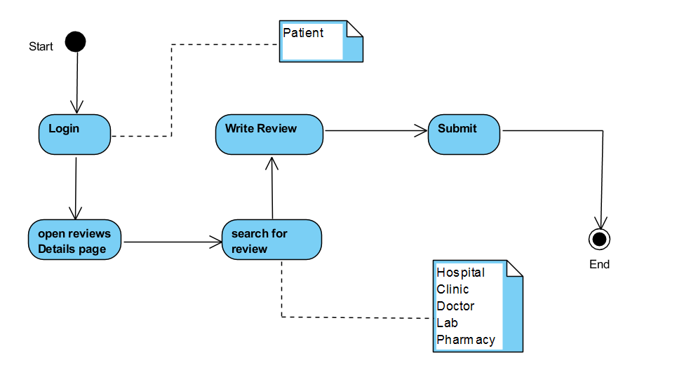

* **Prescription**
* **Reviews**

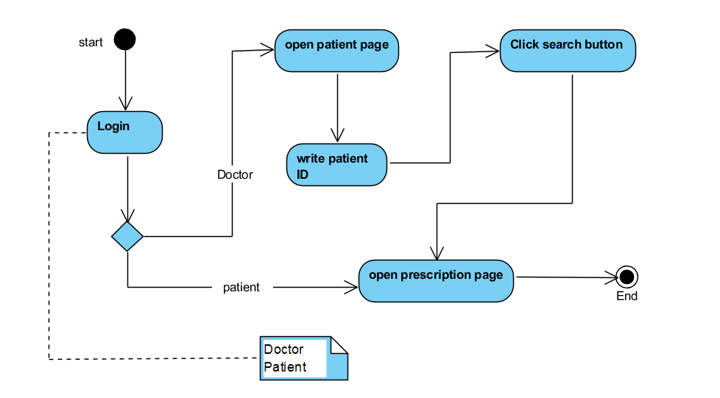

* **Update profile**

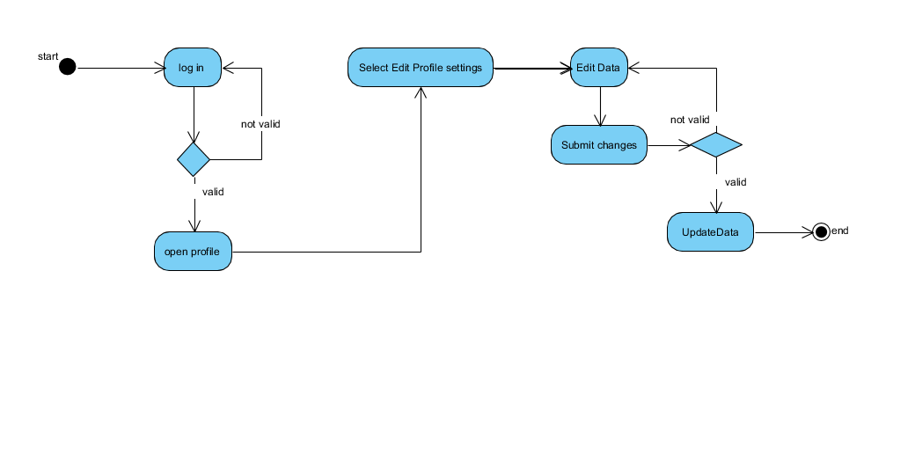

* **Show partners**

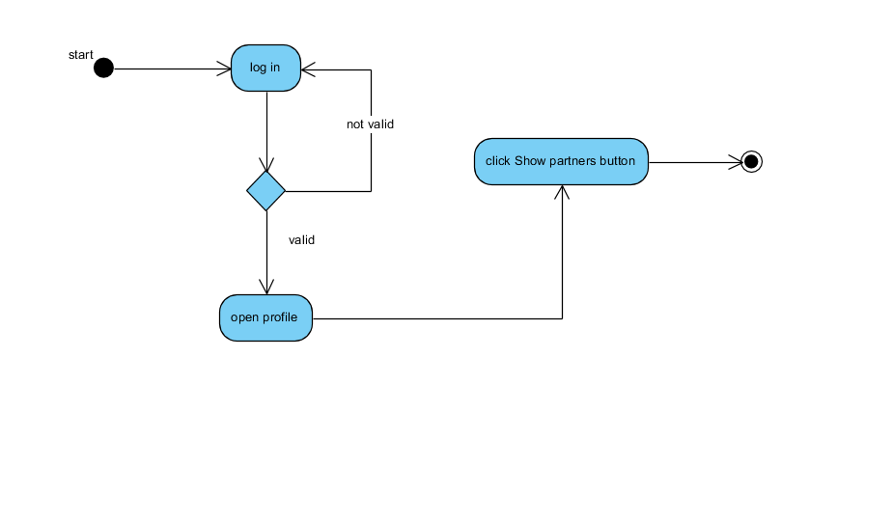

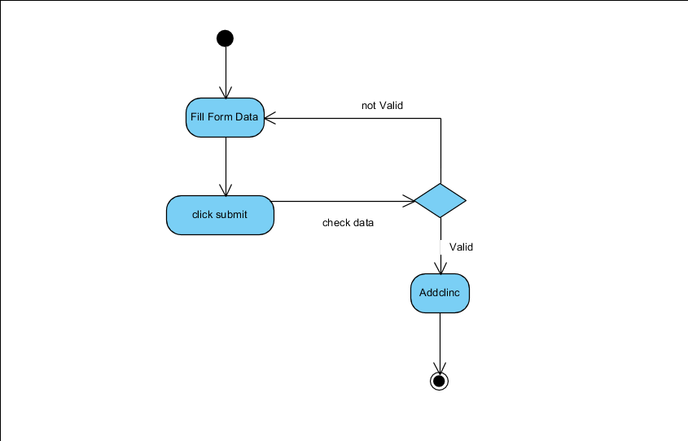

* **Home Page**
* **Add clinic**

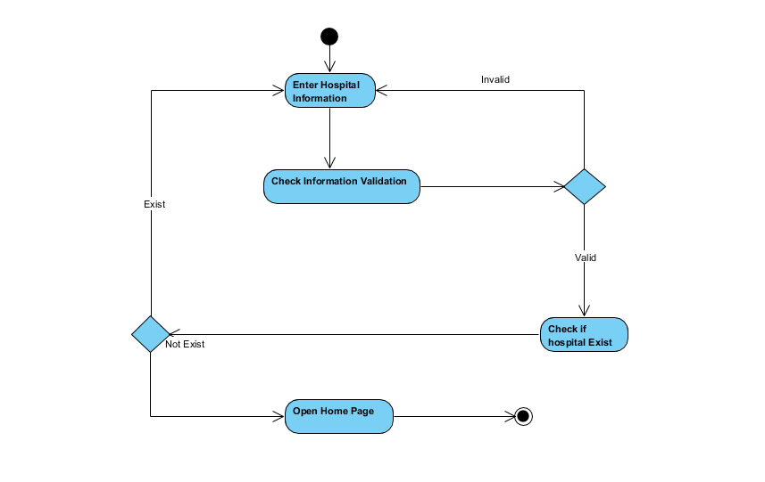

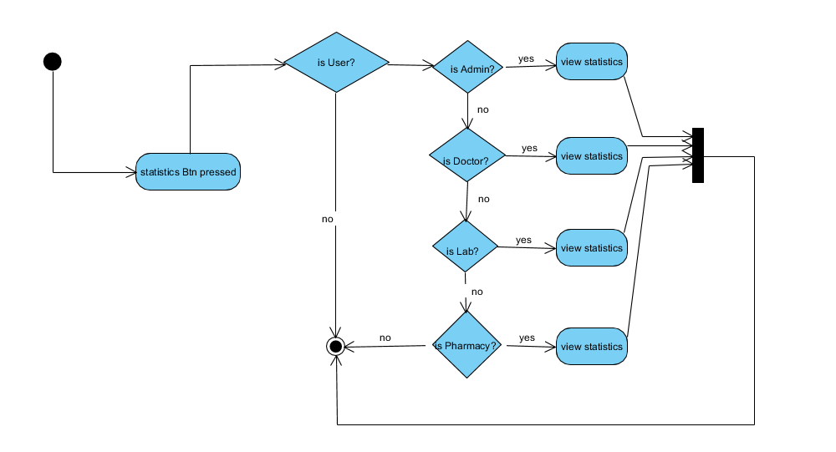

* **Upload x-ray**
* **Statistics**

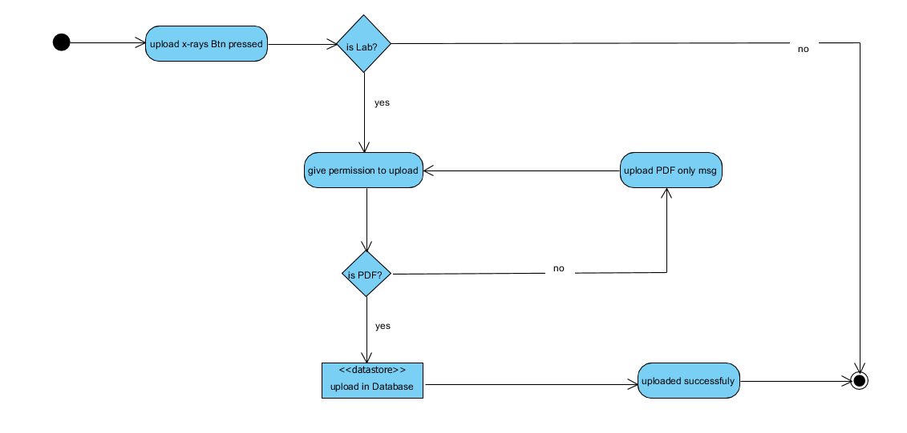

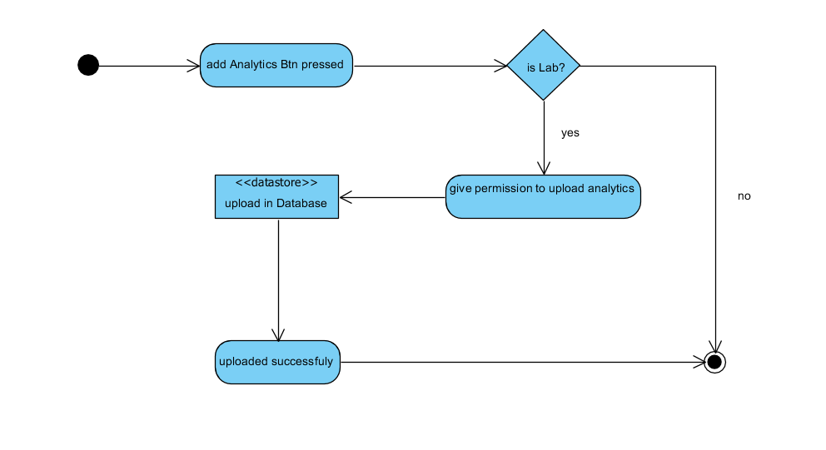

* **Add doctor**
* **Add analytics**

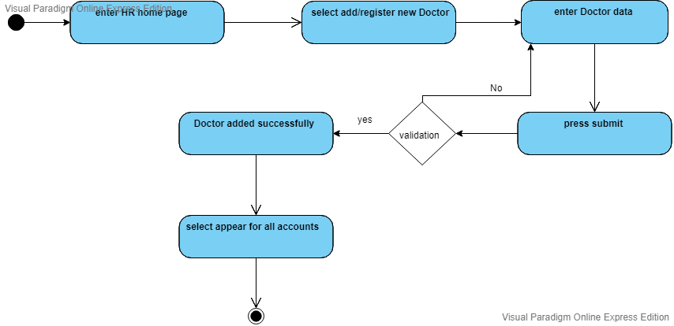

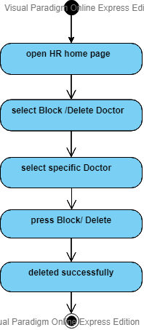

* **Update data**
* **Block doctor**

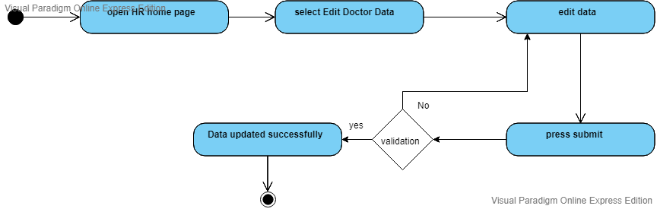

* **search**

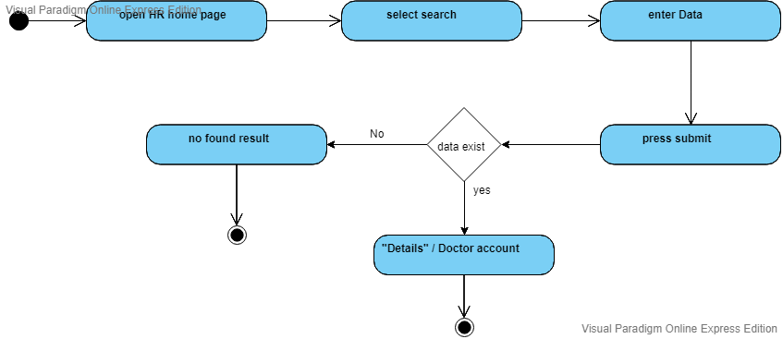

## 3.3 sequence diagram

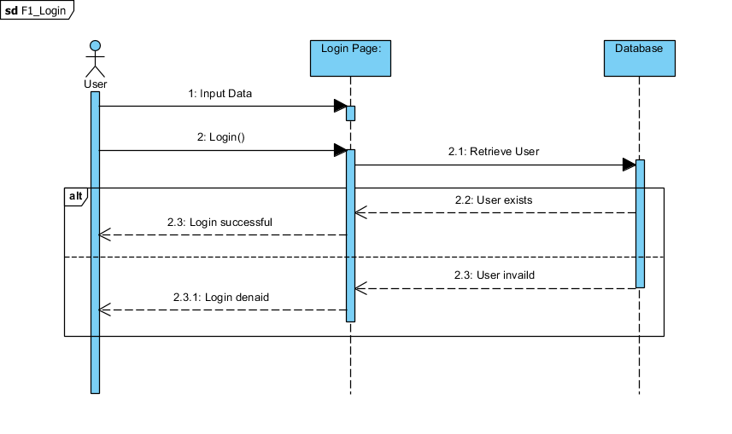

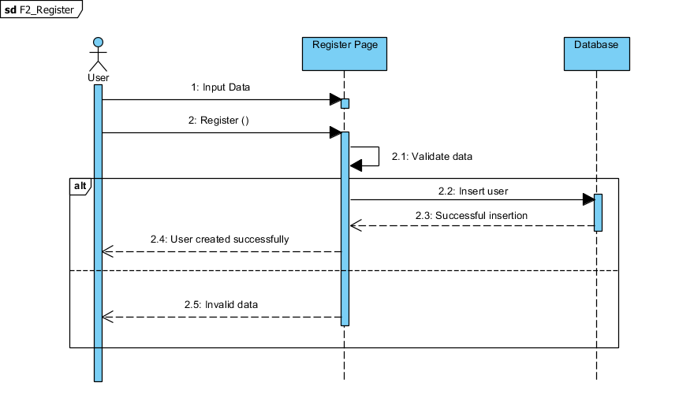

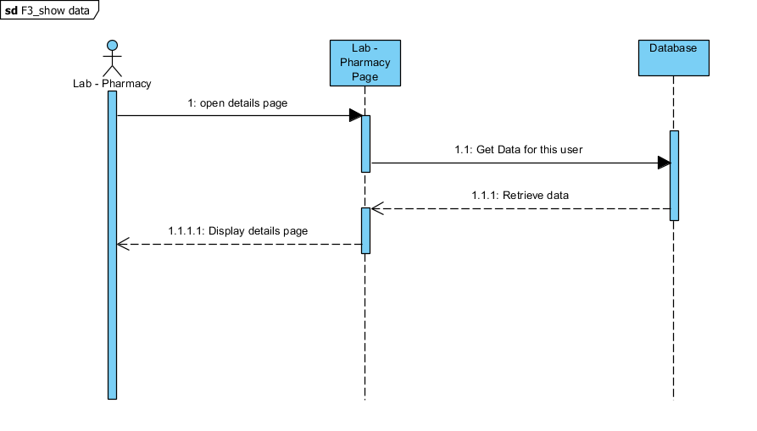

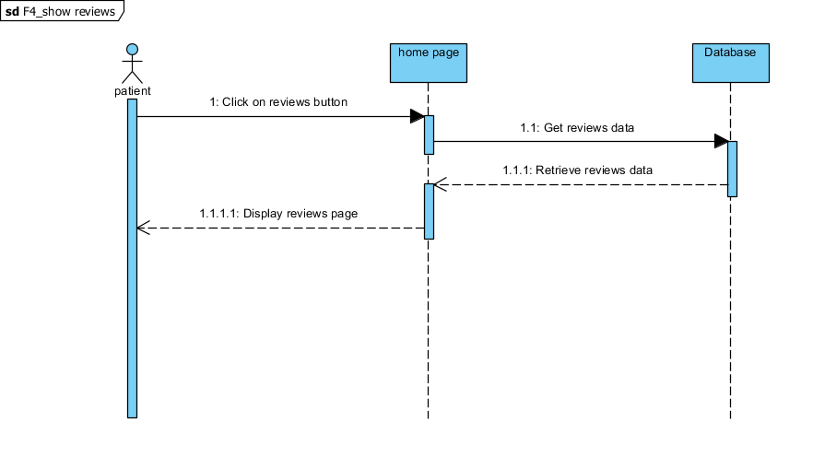

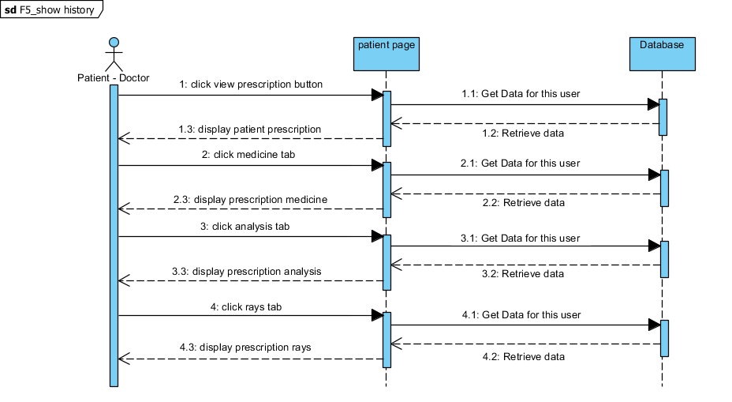

* **update**

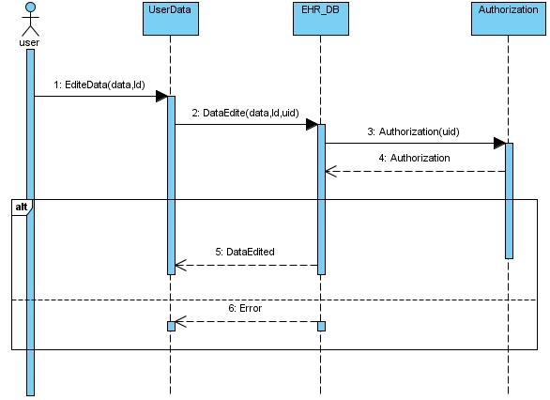

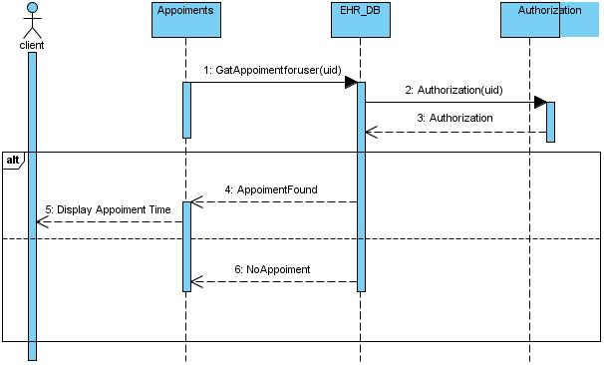

* **View partner info**
* **appointment**

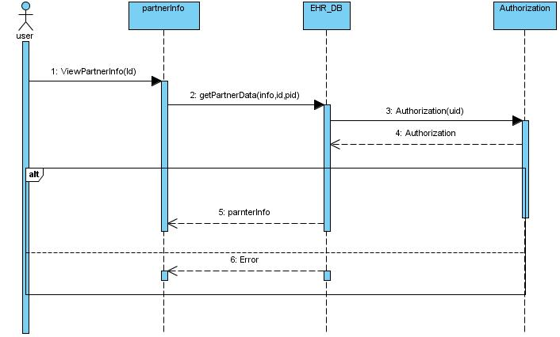

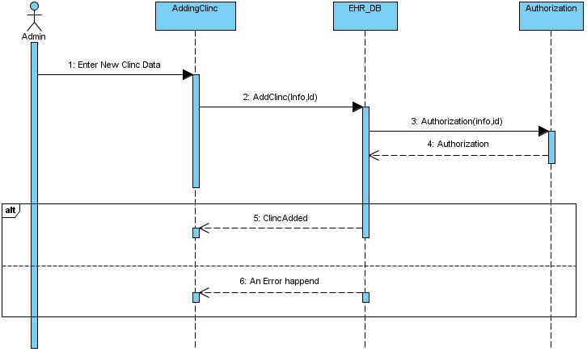

* **Add clinic**

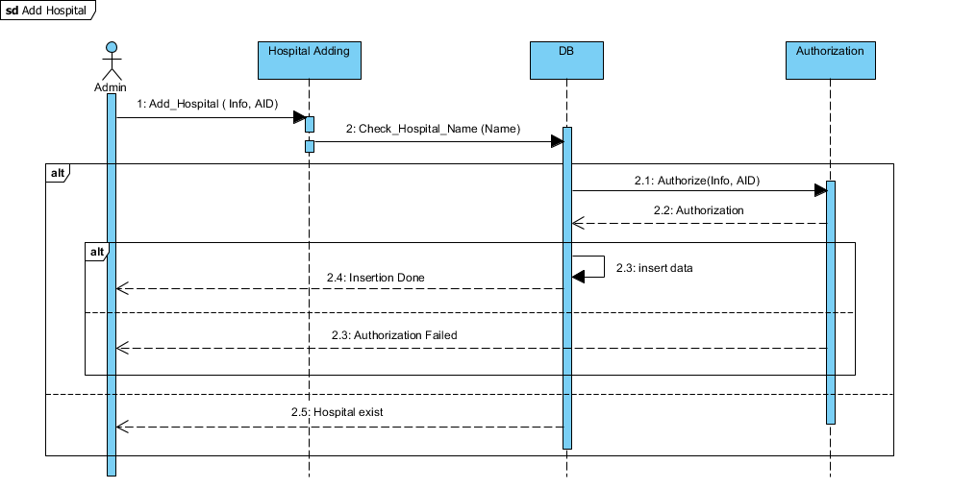

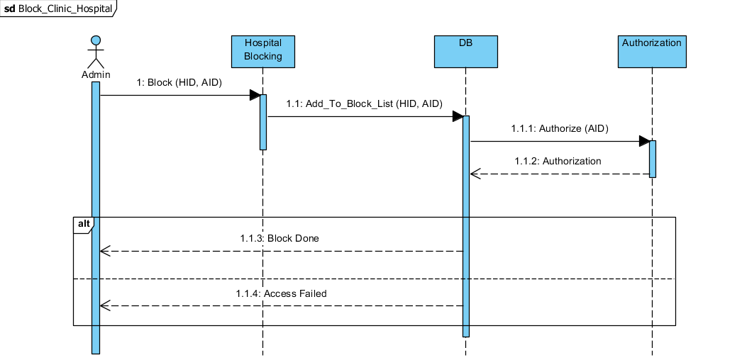

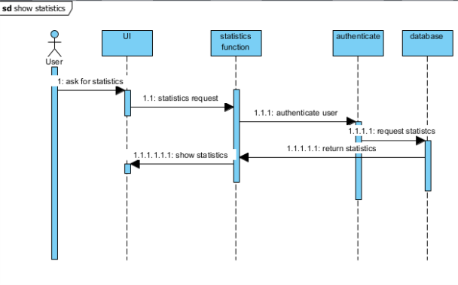

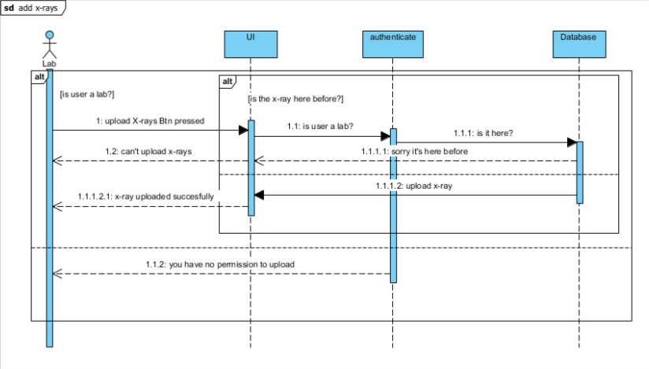

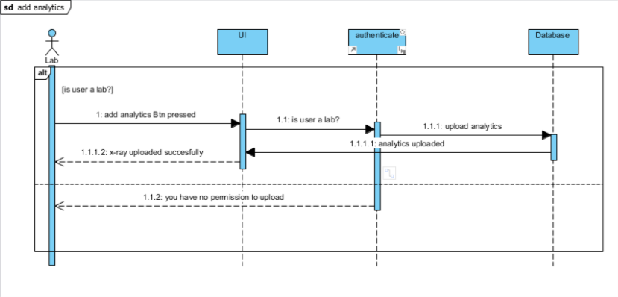

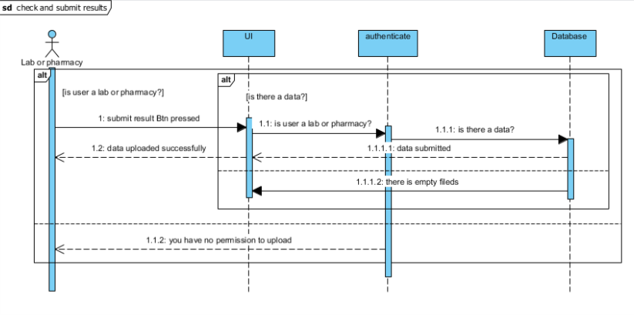

* **Add doctor**

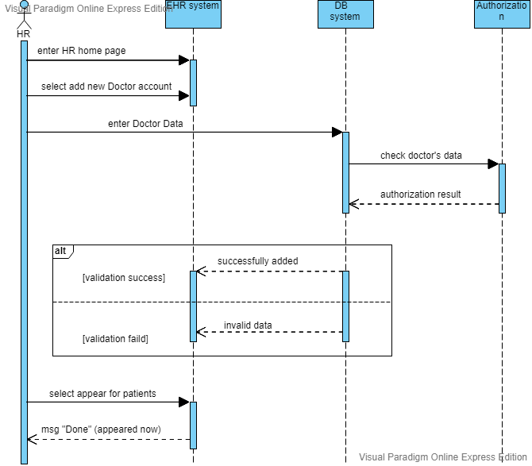

* **Remove/block doctor**

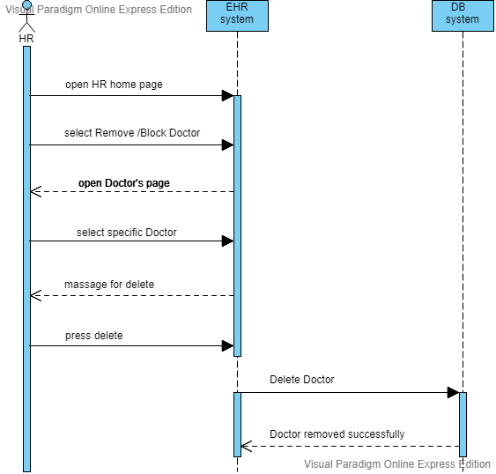

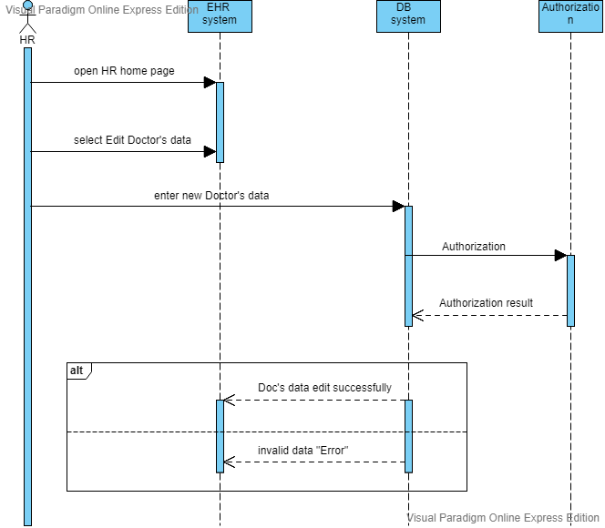

* **search**
* **Edit doctor**

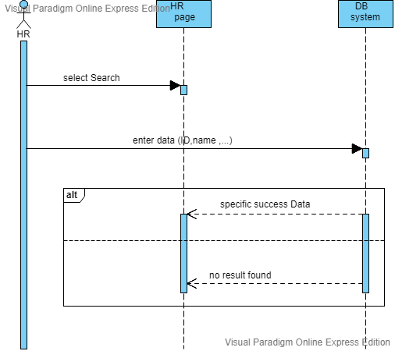

## 3.4 database schema

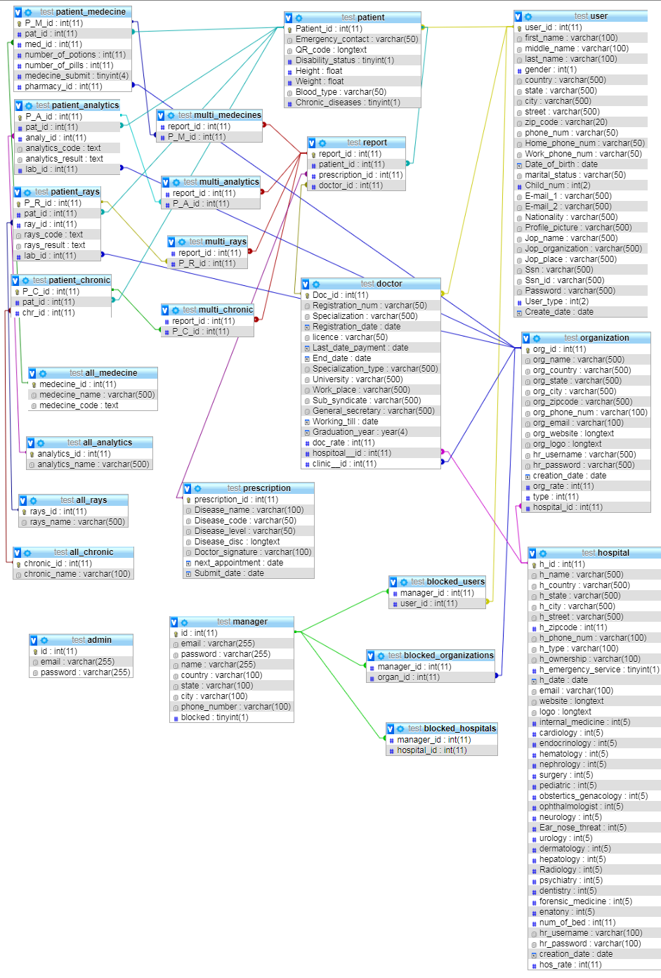

* **Class Diagram**

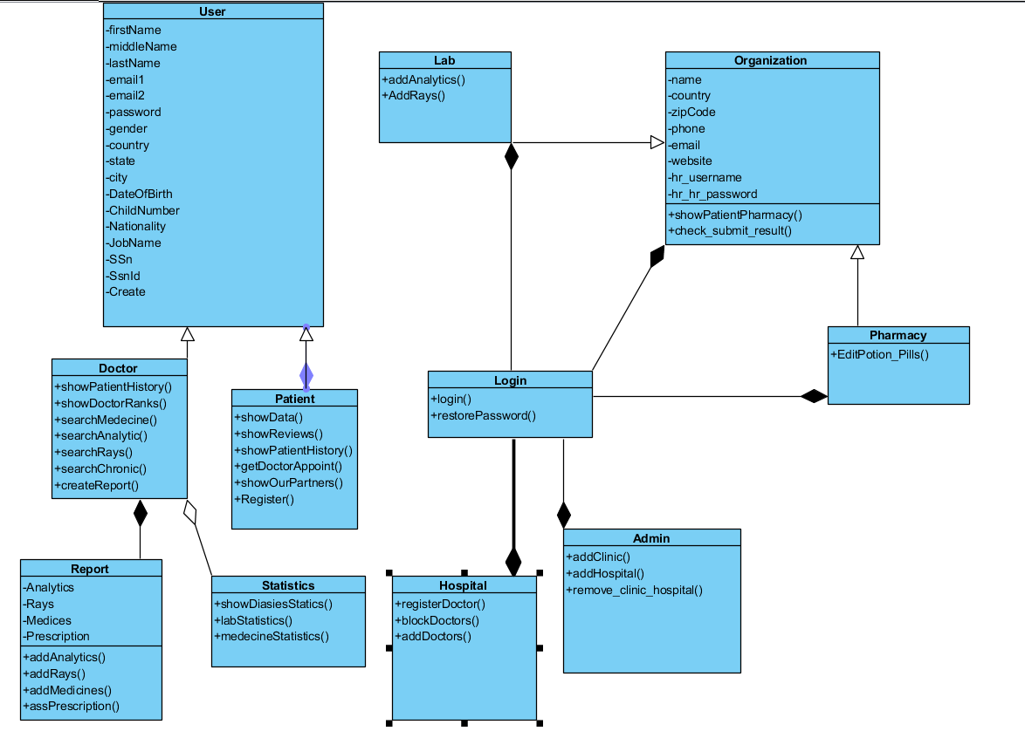



In this chapter we’re going to discuss and go deeper in implementation, and present its code and the algorithms used to build it.

# Chapter 4 : project "implementation "

## 4.1 hardware architecture

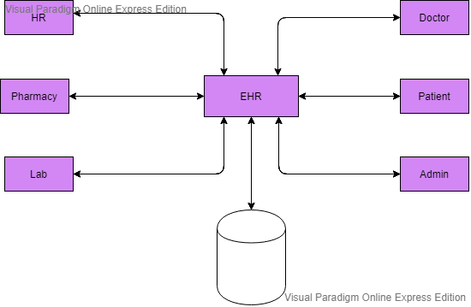

## 4.2 software architecture

**“Web site Architecture”**

1. Sign up

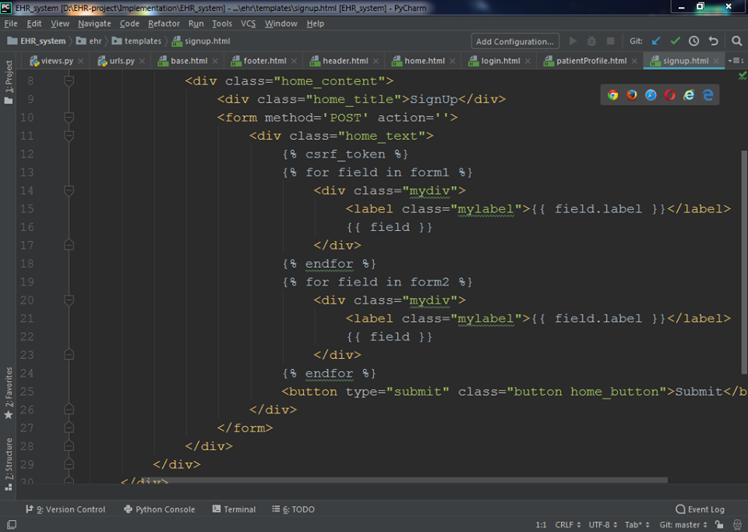

1. Login

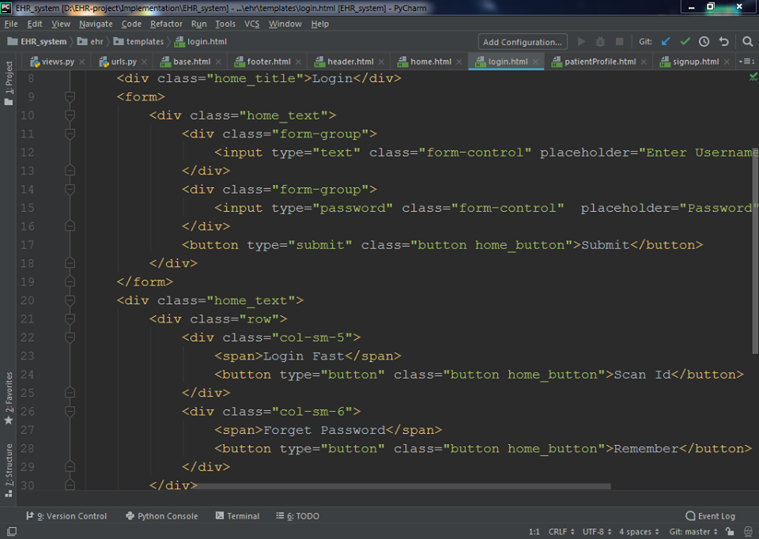

1. Home

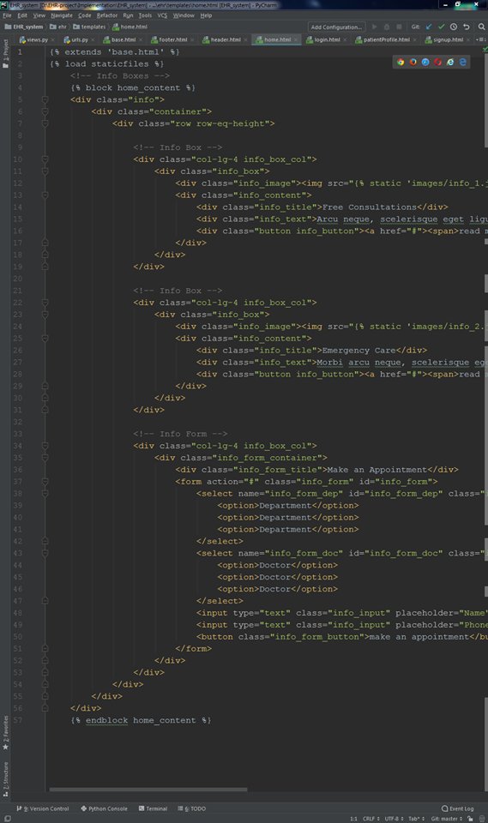

**“Android Architecture”**

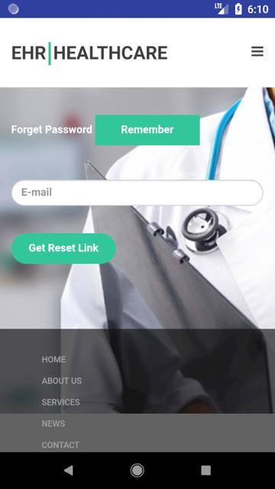 

In this chapter we’re going to discuss and go deeper in EHR

System’s testing, and presents the types of testing to be used and test cases we examined our system through.

**Chapter 5**: Testing

## Functional Testing:

**5.1 Unit Testing**

Testing of individual items (e.g. modules, programs, objects, classes, etc.)Usually as part of the coding phase, in isolation from other development item sand the system as a whole.

**5.2 Integration testing**

Testing the interfaces between major (e.g. systems level application modules) and minor (e.g. individual programs or components) items with in an application which must interact with each other.

**5.3 System testing**

Testing a system behavior as a whole when development is finished and the system can be tested as complete entity.

**5.4 Regression Testing**

To check older functionality after integrating new functionality.

**5.5 Acceptance testing**

Testing to ensure that a development is ready to be deployed into the business, operational or production environment.

## NonFunctional Testing:

**Performance Testing**

Accomplished a designated function regarding processing time and through put rate.

**Load Testing**

Measuring the behavior of within creasing load which can be handled by the component or system.

**Stress Testing**

Evaluate a system or component at or beyond the limits of its specified requirements.

**Security Testing**

Testing how well the system protects against unauthorized internal or external access.

**Test cases**

Test Scenario Objective:

Verify log in successfully with correct email and correct.

1. Project

## 

2. Test Plan

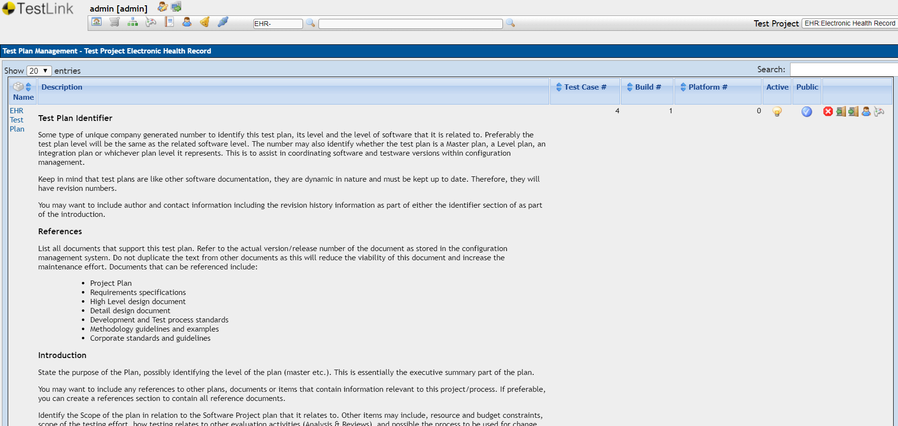

3. Test Requirement

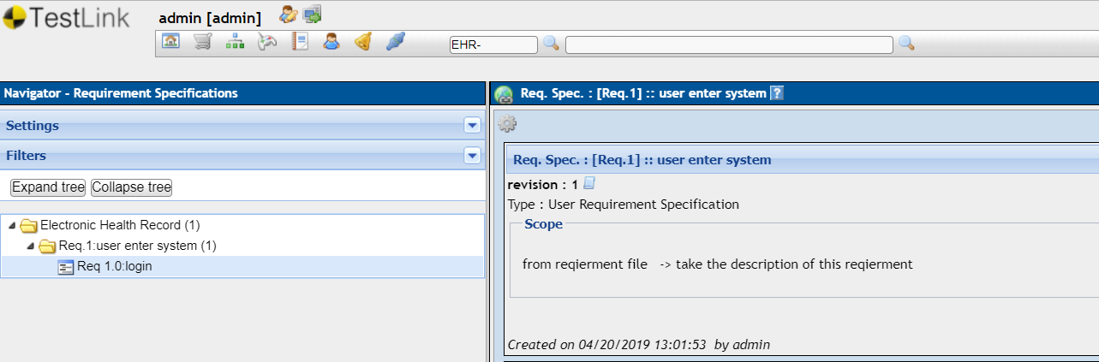

4. Test Suite

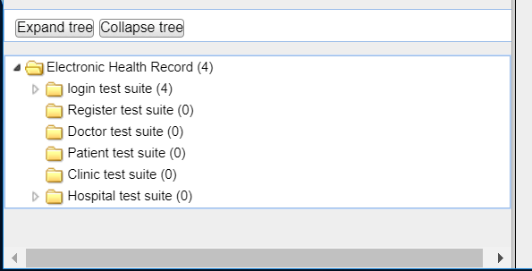

1. Test Case

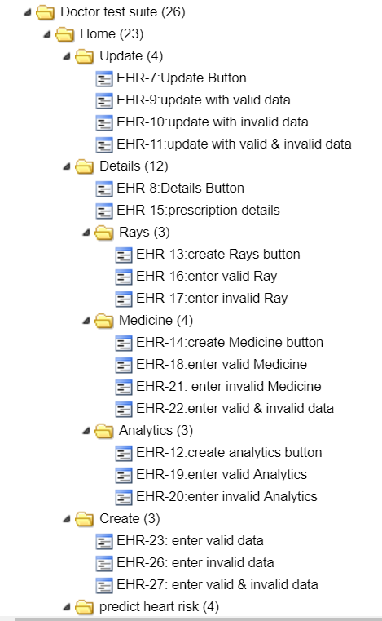

|  |  |  |  |  |
| --- | --- | --- | --- | --- |
| **Test Case EHR-7: Update Button [Version : 1]** | | | | |
| Summary: test update button work | | | | |
| Preconditions: Doctor must be register to our system | | | | |
| #: | Step actions: | Expected Results: | Execution Status: |  |
| 1 | open system | system opened | Passed |  |
| 2 | login | right authenticated login | Passed |  |
| 3 | enter  authenticated patient id | system accepted this patient id | Passed |  |
| 4 | click update button | valid interact to update each all patient prescriptions | Passed |  |
| Execution type: | Manual | | | |
| Priority: | High | | | |
|  | | | | |
| **Execution Details** |  | | | |
| Build | version 1.0 | | | |
| Tester | admin | | | |
| Execution Result: | **Passed** | | | |
| Execution Mode: | **Manual** | | | |

|  |  |  |  |  |
| --- | --- | --- | --- | --- |
| **Test Case EHR-9: update with valid data [Version : 1]** | | | | |
| Summary: test update work | | | | |
| Preconditions: Doctor must be register and login to our system  open system | | | | |
| #: | Step actions: | Expected Results: | Execution Status: |  |
| 1 | click update button | valid interact to update each all patient prescriptions | Passed |  |
| 2 | enter valid information of all prescription | accepted all data and save it | Passed |  |
| Execution type: | Manual | | | |
| Priority: | Medium | | | |
|  | | | | |
| **Execution Details** |  | | | |
| Build | version 1.0 | | | |
| Tester | admin | | | |
| Execution Result: | **Passed** | | | |
| Execution Mode: | **Manual** | | | |

|  |  |  |  |  |
| --- | --- | --- | --- | --- |
| **Test Case EHR-13: create Rays button [Version : 1]** | | | | |
| Summary: test the part of create Rays in Details Button | | | | |
| Preconditions: Doctor must be :  open system  register  login  enter authenticated patient  id | | | | |
| #: | Step actions: | Expected Results: | Execution Status: |  |
| 1 | click details | right interaction | Passed |  |
| 2 | click create Rays button | right interaction by opening a new page to add or create Rays | Passed |  |
| Execution type: | Manual | | | |
| Priority: | Medium | | | |
|  | | | | |
| **Execution Details** |  | | | |
| Build | version 1.0 | | | |
| Tester | admin | | | |
| Execution Result: | **Passed** | | | |
| Execution Mode: | **Manual** | | | |

|  |  |  |  |  |
| --- | --- | --- | --- | --- |
| **Test Case EHR-20: enter invalid Analytics [Version : 1]** | | | | |
| Summary: Testing create Analytics with invalid data | | | | |
| Preconditions: Doctor must be :  open system  register  login  enter authenticated patient  id | | | | |
| #: | Step actions: | Expected Results: | Execution Status: |  |
| 1 | click details | right interaction | Passed |  |
| 2 | click create Analytics button | right interaction by opening a new page to add or create Analytics | Passed |  |
| 3 | add invalid data of  Analytics |  | Passed |  |
| 4 | click create | system refused  show massage with Analytics is not added please enter valid data of Analytics | Passed |  |
| Execution type: | Manual | | | |
| Estimated exec. duration (min): |  | | | |
| Priority: | Medium | | | |
|  | | | | |
| **Execution Details** |  | | | |
| Build | version 1.0 | | | |
| Tester | admin | | | |
| Execution Result: | **Passed** | | | |
| Execution Mode: | **Manual** | | | |

1. Execute Test Cases

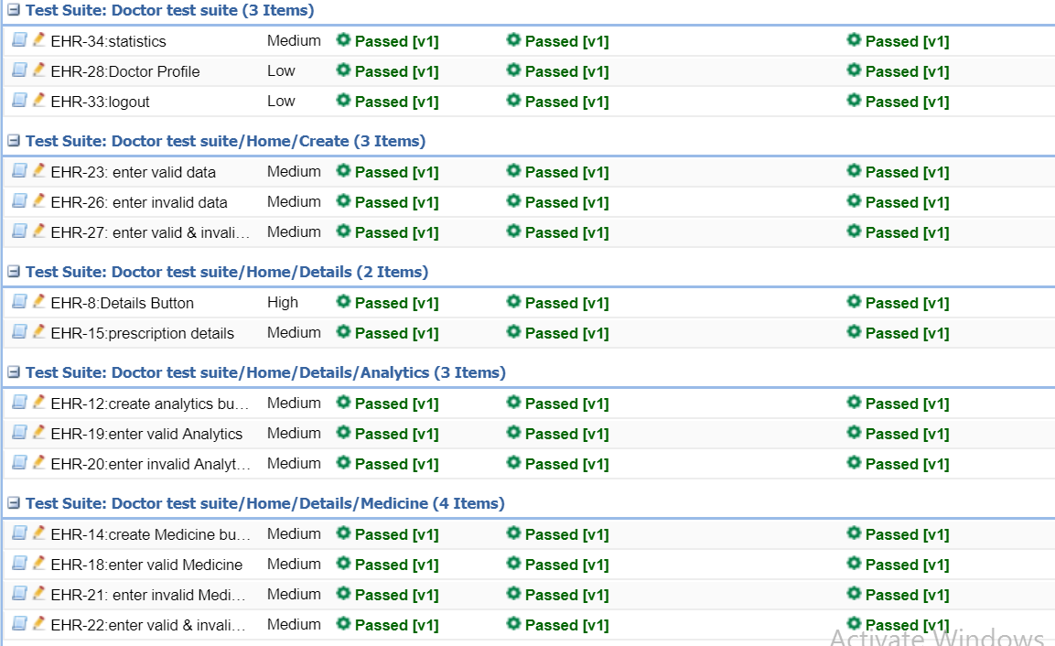

Conclusion

Eventually, in this project we tried to make the best we can to avoid any usage of medical paper and it’s just a way of expressing our duty towards our society as we felt responsible enough to participate in making this community a better place with one of the most powerful tools we can use and we chose as our studying field years ago which is TECHNOLOGY.

In summary, our society would be more convenient if we got rid of any manual technique and more people used this application will move our society for a high level of awareness. We should continue to try to help people make the best choices with no need to any kind of blackmail and do anything with small effort.

We tried to do that with our limited fund and resources and we’re sure we’re going to expand this application and enhance its performance and fame if we’re just given the right resources and fund.

Finally, realizing the fact that “a few clicks” can do a lot to a society, will definitely make us more aware of the technology role and become better versions of ourselves.

**Thanks**